**Sub catchment information**

|  |  |  |  |
| --- | --- | --- | --- |
| **Subcatchment ID** | **Slope *Si* [m/m]** | **Area *Ai* [m2]** | **Width *Wi* [m]** |
| **6287** | 0.158 | 0.42 | 77 |
| 6296 | 0.565 | 0.23 | 40 |
| 25107 | 0.263 | 0.28 | 39 |
| 25108 | 0.326 | 0.24 | 27 |
| 25109 | 0.308 | 0.48 | 47 |
| 25110 | 0.263 | 0.33 | 41 |
| 25117 | 0.087 | 0.53 | 56 |
| 25119 | 0.364 | 0.19 | 33 |
| 25120 | 0.323 | 0.34 | 55 |
| 25121 | 0.263 | 0.16 | 41 |
| 25122 | 0.278 | 0.39 | 56 |
| 25123 | 0.167 | 0.71 | 59 |
| 25124 | 0.247 | 0.37 | 45 |
| 25125 | 0.357 | 0.28 | 69 |
| 25126 | 0.294 | 0.05 | 31 |
| 25127 | 0.500 | 0.02 | 30 |
| 25129 | 0.481 | 0.41 | 76 |
| 25130 | 0.490 | 0.19 | 35 |
| 25131 | 0.400 | 0.15 | 31 |
| 25132 | 0.395 | 0.18 | 39 |
| 25133 | 0.455 | 0.06 | 14 |
| 25135 | 0.259 | 0.18 | 41 |
| 25136 | 0.362 | 0.27 | 47 |
| 25977 | 0.405 | 0.45 | 107 |
| 27169 | 0.266 | 0.49 | 71 |
| 28233 | 0.097 | 0.89 | 125 |

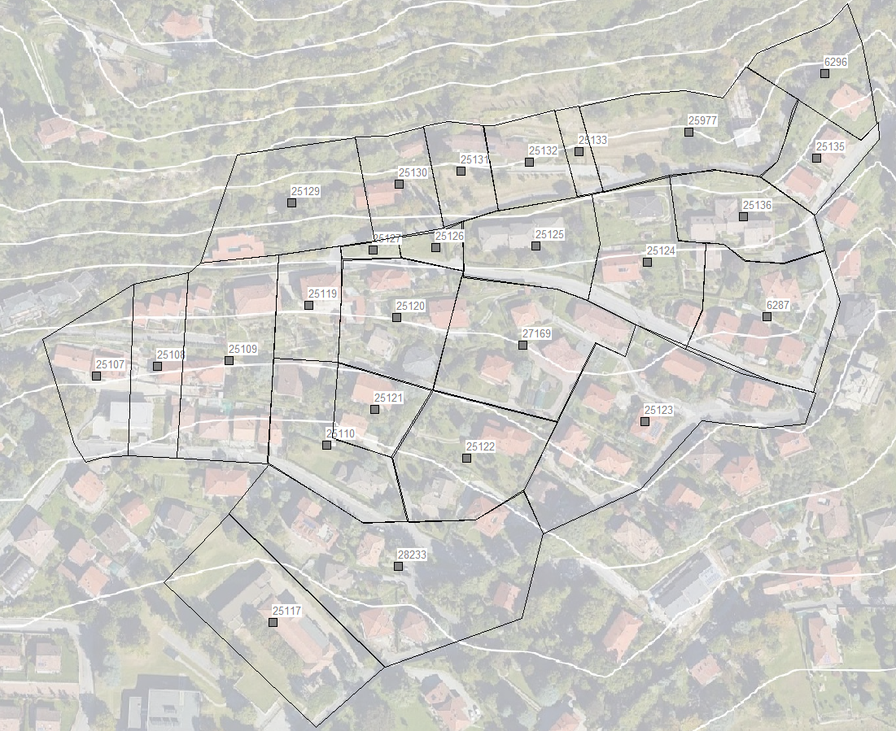

**Node Information**

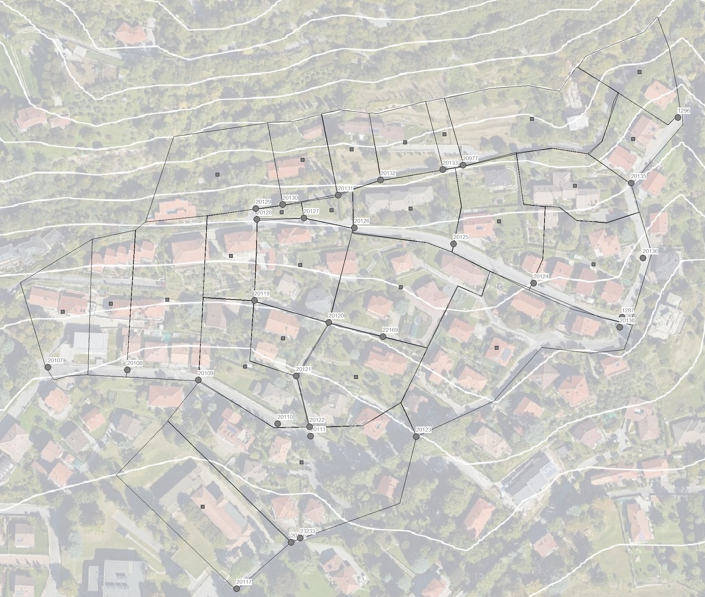

|  |  |  |
| --- | --- | --- |
| **Node ID** | Surface Elevation *zj* [m.a.s.l] | Node Depth *Ϛj* [m] |
| 20977 | 440.92 | 0.52 |
| 20133 | 440.08 | 1.05 |
| 20132 | 437.13 | 1.12 |
| 20131 | 435.1 | 0.95 |
| 20130 | 432.58 | 0.87 |
| 20129 | 431.46 | 1.05 |
| 20128 | 430.78 | 1.57 |
| 20127 | 428.96 | 0.95 |
| 20126 | 427.12 | 1.22 |
| 20125 | 422.49 | 1.12 |
| 20124 | 418.54 | 1.12 |
| 1296 | 435.34 | 1.13 |
| 20135 | 432.53 | 1.48 |
| 20136 | 423.02 | 1.26 |
| 1287 | 415.81 | 0.9 |
| 20138 | 415.81 | 1.44 |
| 20123 | 399.1 | 1.47 |
| 20119 | 410.86 | 0.96 |
| 20120 | 409.07 | 1.27 |
| 22169 | 409.39 | 1.1 |
| 20121 | 401.34 | 1.47 |
| 20122 | 395.68 | 1.18 |
| 20107 | 400.03 | 1.28 |
| 20108 | 399.24 | 1.65 |
| 20109 | 397.98 | 1.26 |
| 20110 | 394.88 | 0.92 |
| 20111 | 394.77 | 1.35 |
| 23233 | 385.6 | 0.6 |
| 20116 | 385.86 | 1.42 |
| 20117 | 382.15 | 1.3 |

**Conduit Information**

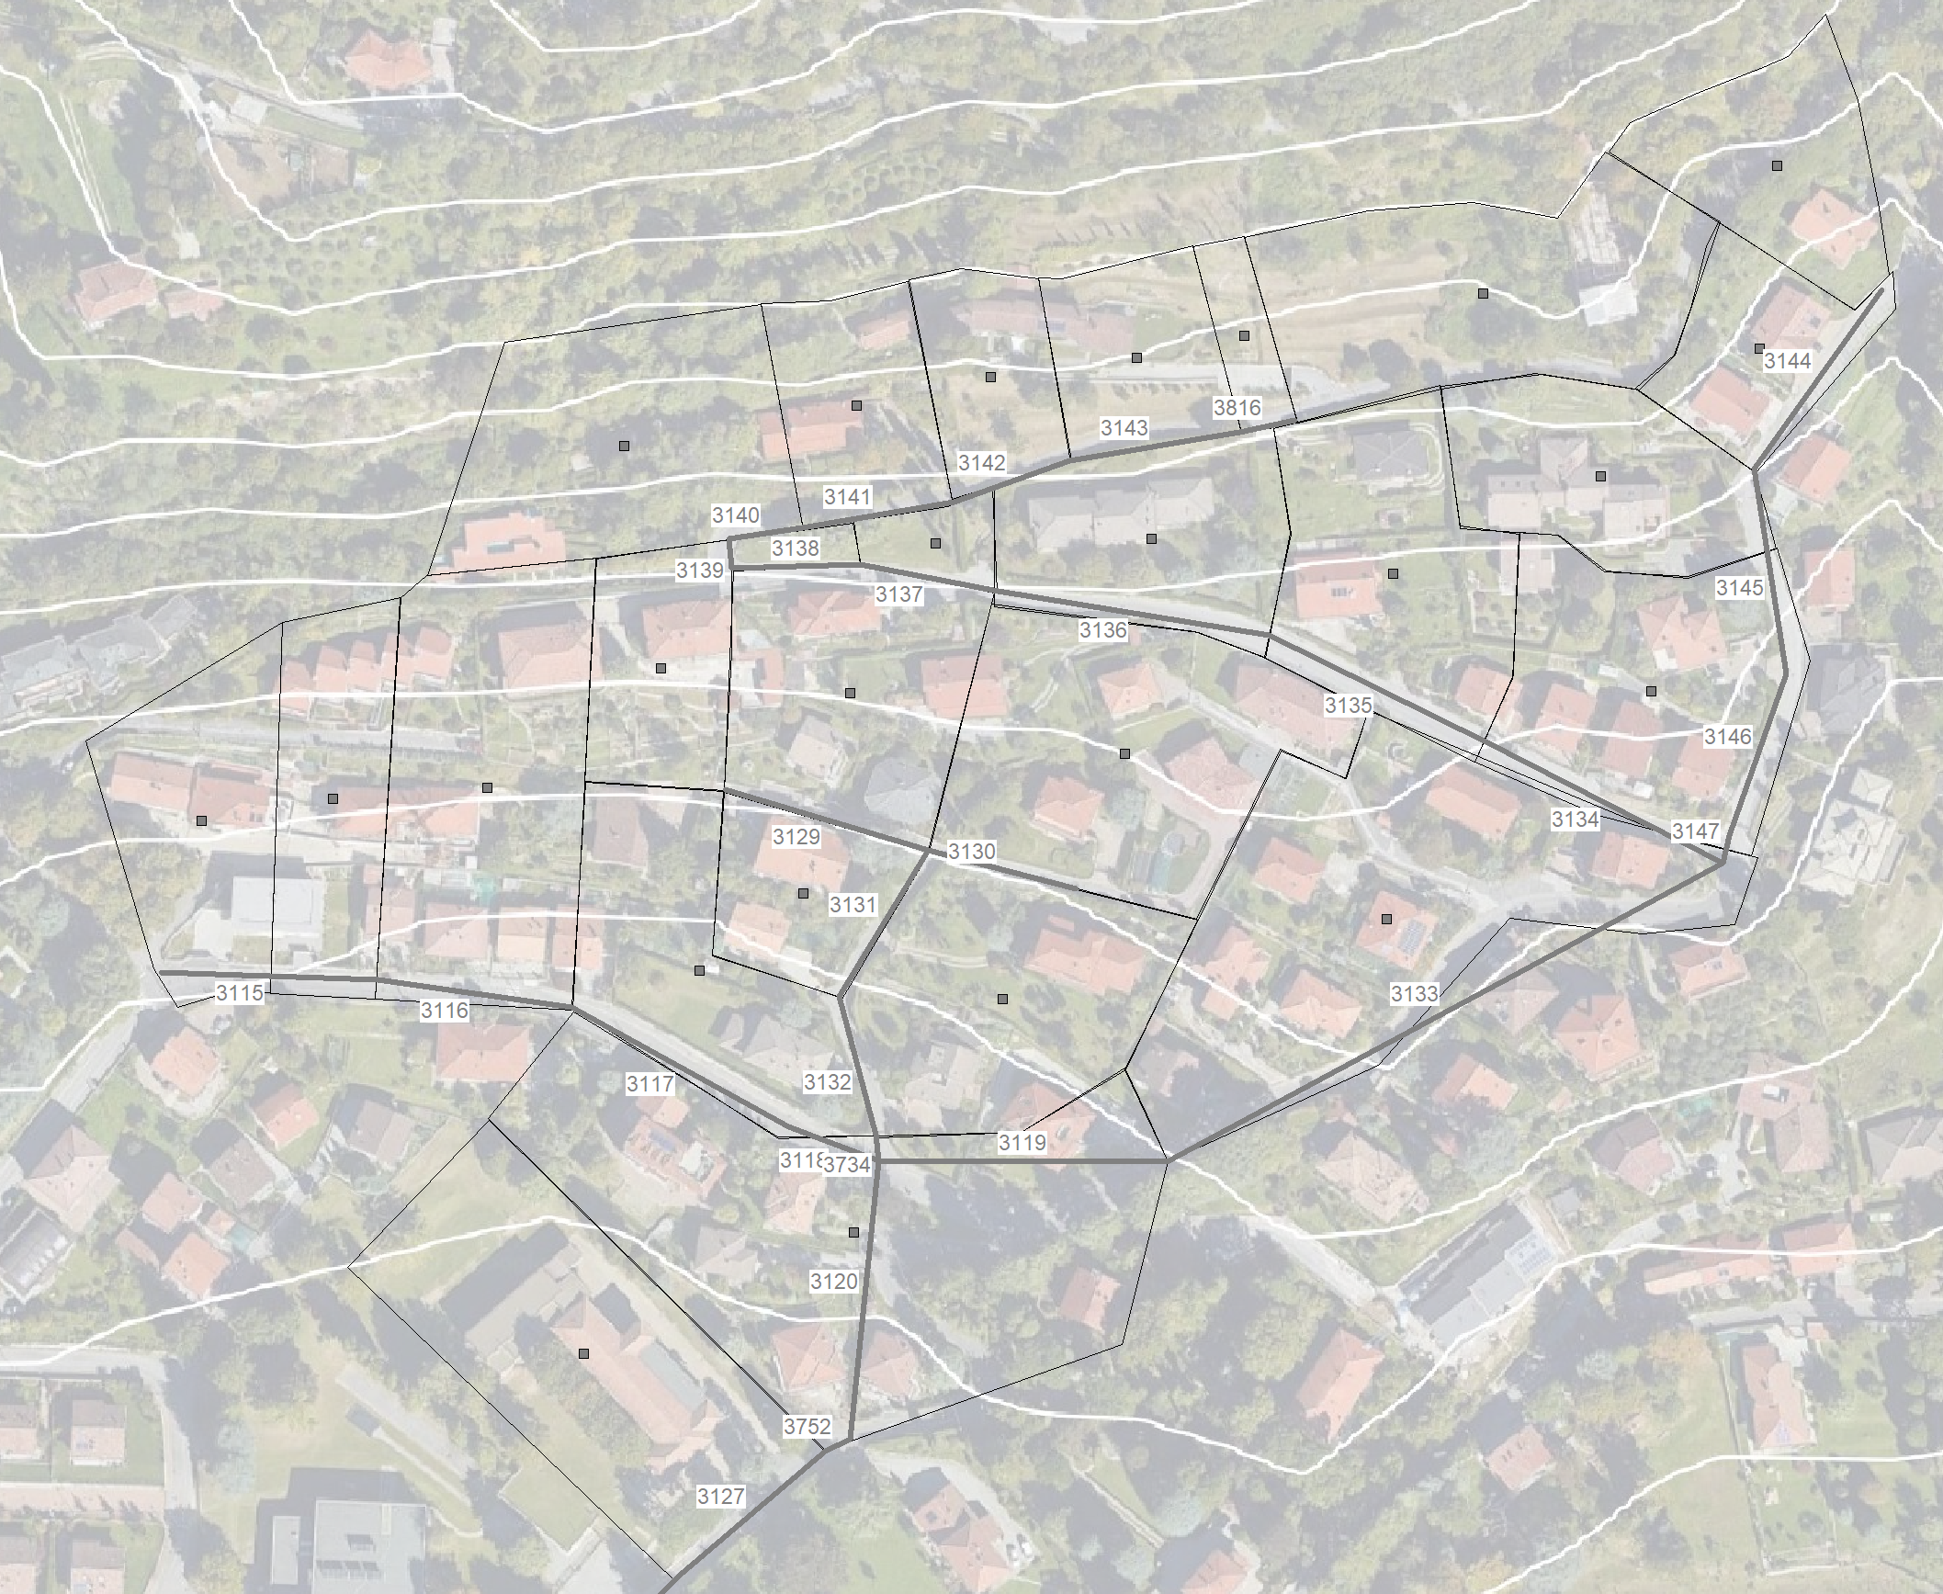

|  |  |  |
| --- | --- | --- |
| **Conduit** | Length [m] | Diameter [cm] |
| 3816 | 13.52 | 25 |
| 3143 | 41.32 | 25 |
| 3142 | 29.06 | 25 |
| 3141 | 36.8 | 25 |
| 3140 | 17.66 | 25 |
| 3139 | 7.13 | 25 |
| 3138 | 30.65 | 25 |
| 3137 | 33.34 | 25 |
| 3136 | 65.78 | 30 |
| 3135 | 57.93 | 30 |
| 3134 | 64.34 | 40 |
| 3144 | 52.35 | 20 |
| 3145 | 50.12 | 20 |
| 3146 | 41.31 | 20 |
| 3147 | 6.63 | 20 |
| 3133 | 161.03 | 30 |
| 3119 | 73.6 | 30 |
| 3129 | 50.46 | 25 |
| 3130 | 36.38 | 25 |
| 3131 | 40.78 | 25 |
| 3132 | 34.63 | 25 |
| 3734 | 6.15 | 30 |
| 3115 | 51.84 | 30 |
| 3116 | 46.76 | 30 |
| 3117 | 59.14 | 30 |
| 3118 | 22.99 | 30 |
| 3120 | 100.31 | 30 |
| 3752 | 6.73 | 50 |
| 3127 | 46.69 | 50 |
| 3121 | 58.87 | 50 |